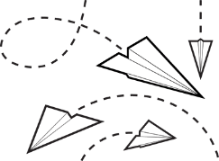
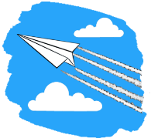
Paper AirPlanedemonium

Scientific Question: Does the ______________ of a
paper airplane affect how far it flies and of three paper
Types,______________________,________________________, and____________________, which will fly the farthest and stay in the air longest?

Hypothesis: I think that the _______________ of a plane ___________________ affect how far it flies and that the _________________________ plane will fly the farthest because: _____________________________
____________________________________________________________________________________________________________________________________________________________________________________
Variables:
Dependent_______________________________ Independent ____________________________________
Controls___________________________________________________________________________________

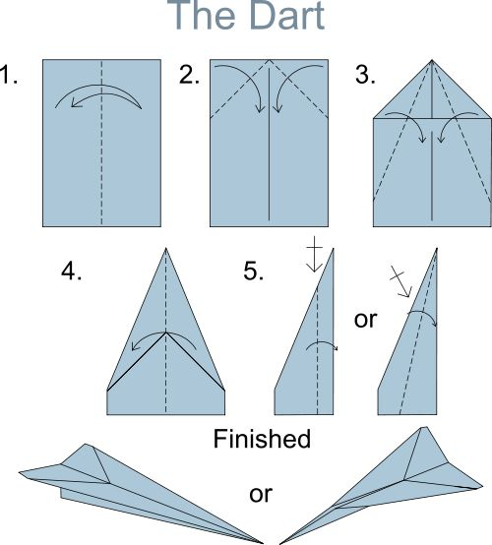
Procedure:
- In your group of three, make a paper airplane dart out of each of the three paper types. You will have three planes.
- Decorate your planes so your group can identify them. Also, include at least one group member’s name on each plane.
- Using an electronic balance, measure and record the mass of each plane in the data table on the back of this page.
- Determine who in your group will be throwing, timing, and measuring the distance of each throw and record your names at the bottom of this page.
- In the gym, follow the teacher’s instructions and begin throwing your planes. The teacher will give you time to practice throwing.
- Complete ten trials (throws) for each paper airplane and record the distance and time for each trial in the data table on the back of this page.
- Record observations about how each of the planes flies.
- Find the average distance and time for each type of plane.
- Answer the lab questions on the back of this page.

Thrower | Timer | Distance Measurer

Data:
Mass of Planes in Grams | Construction | Printer | Notebook

Distance of Plane Flight in meters (m) |  |  |  |  | Time of Plane Flight in seconds
Trial | Construction | Printer | Notebook |  | Trial | Construction | Printer | Notebook
1 |  |  |  |  | 1
2 |  |  |  |  | 2
3 |  |  |  |  | 3
4 |  |  |  |  | 4
5 |  |  |  |  | 5
6 |  |  |  |  | 6
7 |  |  |  |  | 7
8 |  |  |  |  | 8
9 |  |  |  |  | 9
10 |  |  |  |  | 10
Average |  |  |  |  | Average

Observations:
Lab Questions:
1.Which type of plane had the farthest average distance?
2.Which type of plane had the longest average flight time?
3.Explain why your hypothesis was supported or not supported:

4.What was the purpose of the controls in this experiment?

5. If you were going to do this experiment again, what would you do differently?
6. What else could you test that might have an effect on paper airplane flight distance and time?

